**Experiment – 2.1**

**Student Name: Milan Sharma UID: 23MAI10011**

**Branch: CSE Section/Group: AIML**

**Semester: 1 Date of Performance:**

**Subject Name:** **ARTIFICIAL INTELLIGENCE LAB Code: 23CSH-621.**

**Aim:**

Download recent research dataset from UCI Machine learning repository and train 5 machine learning classifiers for choosing the best prediction model.

**Task to be done:**

* To apply download the dataset from UCL machine learning repositry
* Train 5 machine learning repository and choose the best prediction model

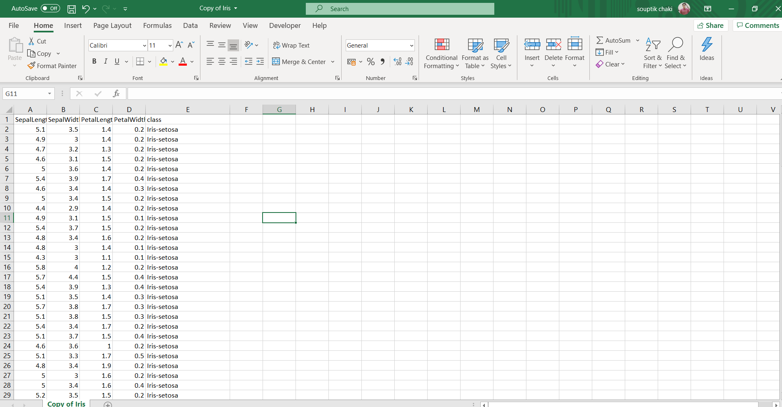

**Procedure:**

1. **Tool to be used for given data set :-**

* Open weka and instead of opening the explorer tab open the experimenter tab
* Click on the new option to initiate the process of adding data
* In the dataset section click on Add new option and select the csv file which you want to import.

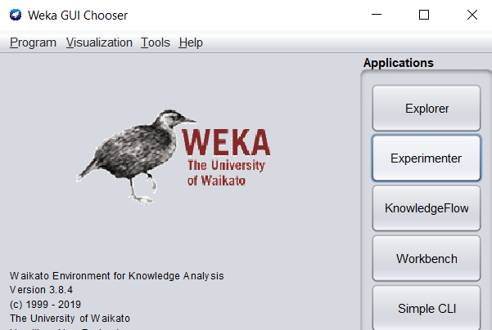

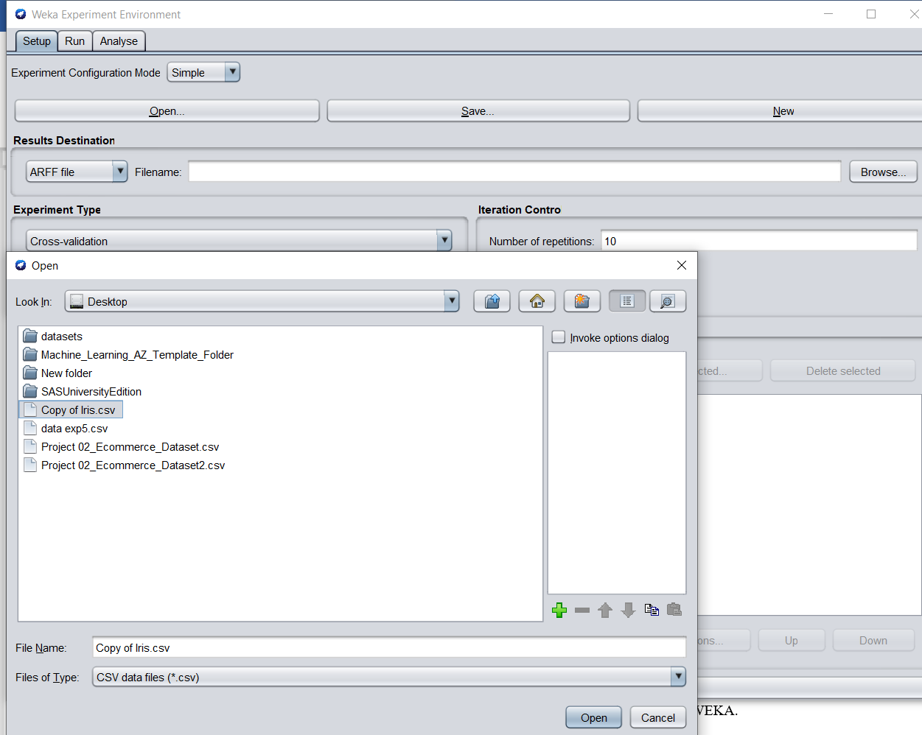

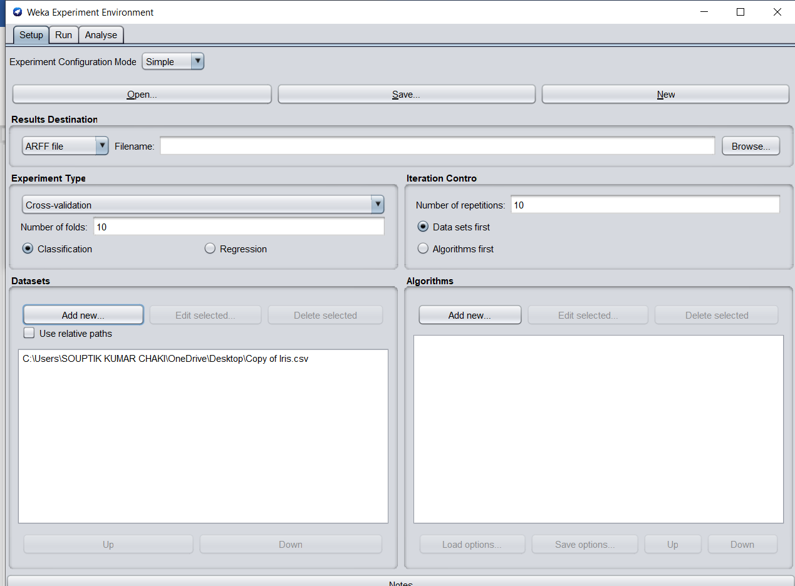

1. **Train 5 machine learning repository and choose the best prediction model :-**

We can apply the 5 machine learning models as follows:-

* In the algorithms section,click on choose add new> choose>>zeroR
* In the algorithms section,click on choose add new> choose>>naivebayes
* In the algorithms section,click on choose add new> choose>>Randomforest
* In the algorithms section,click on choose add new> choose>>j48
* In the algorithms section,click on choose add new> choose>>IBK(KNN classifier)
* click on Run tab >> click start
* After the execution is completed in run tab >>click on analyse tab
* In the analyse tab >> click on experiment tab >> all the options will become active
* In the configure test section >> click on test base>> and select Ranking>>click on perform test
* After check the result in test area ,it will show the algorithms which have performed better and will display the ranking.
* To check the f-measure and std_dev of an particular algorithm >>click on std_tab >>then select the algorithm which you want to test >> select f-measure from the comparison_fied tab
* click on perform test.

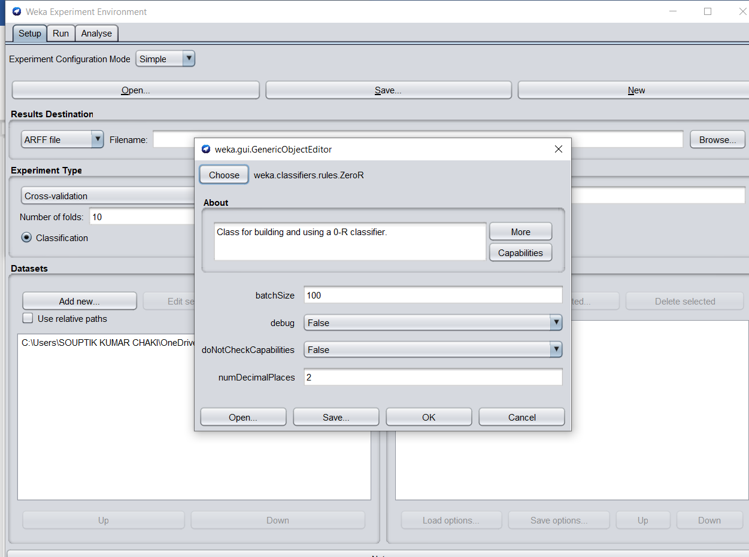

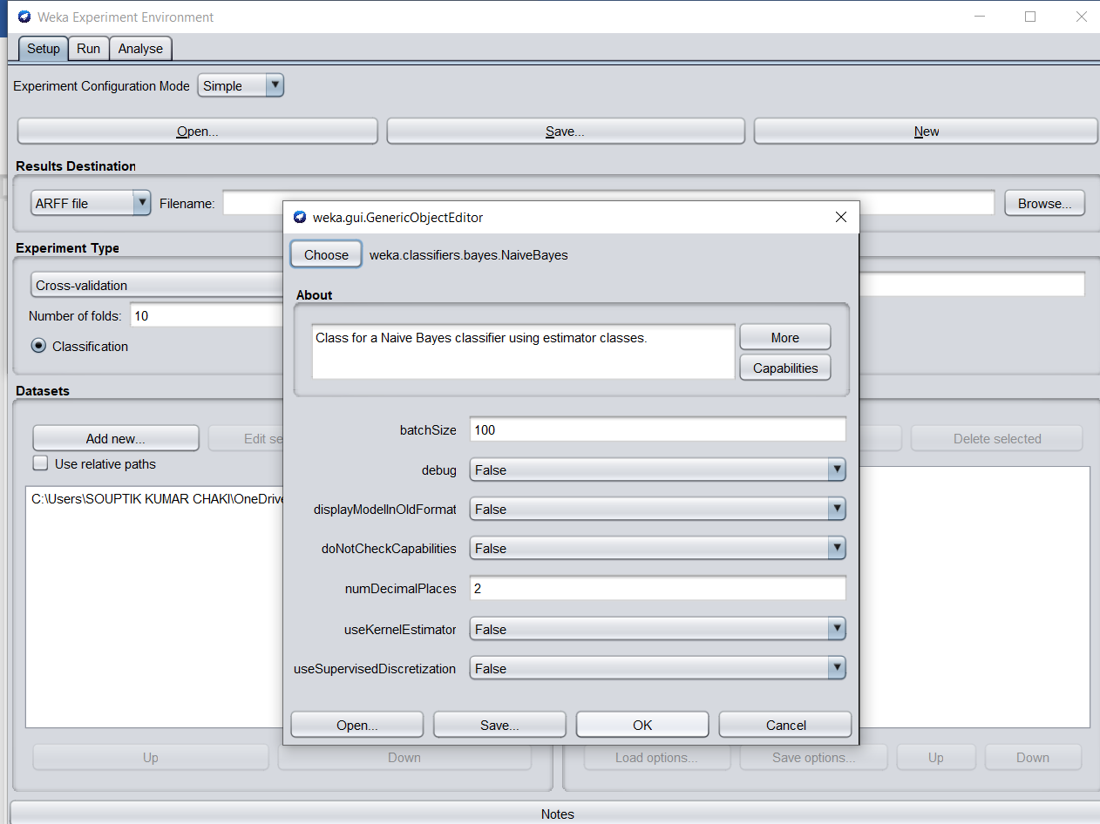

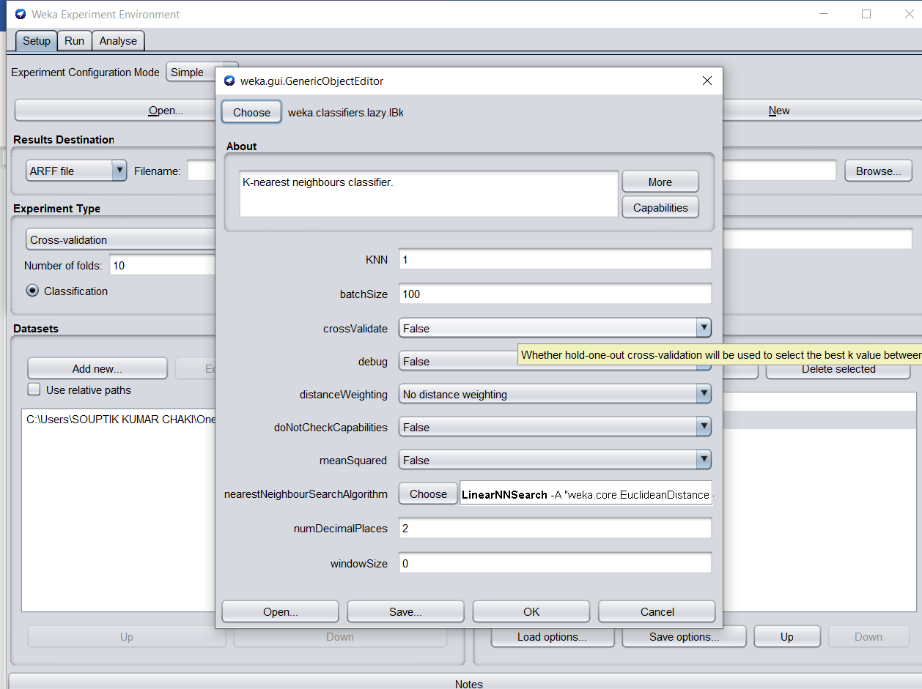

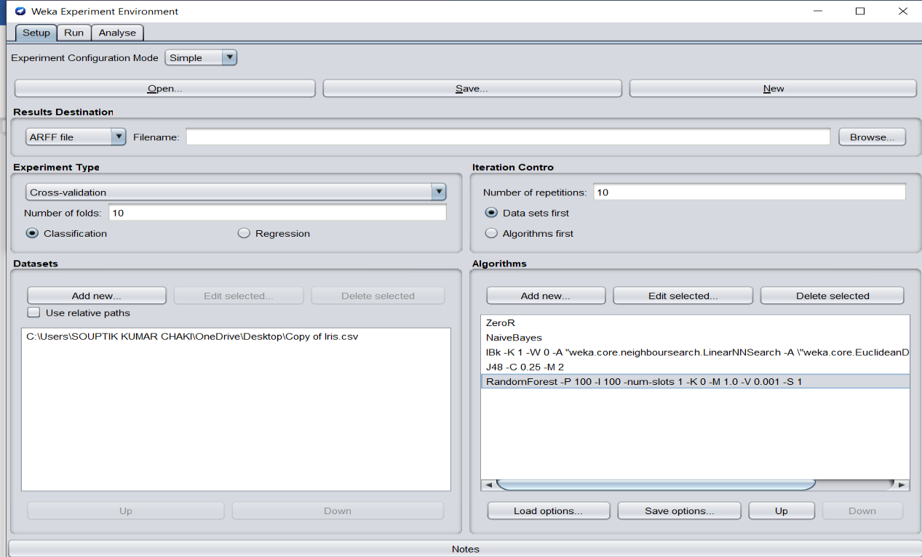

**Run process output:-**

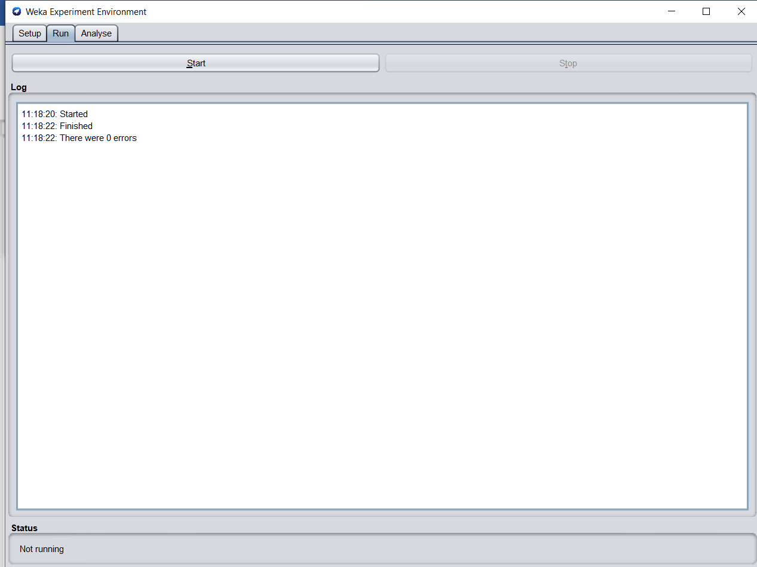

**Analyse process output:-**

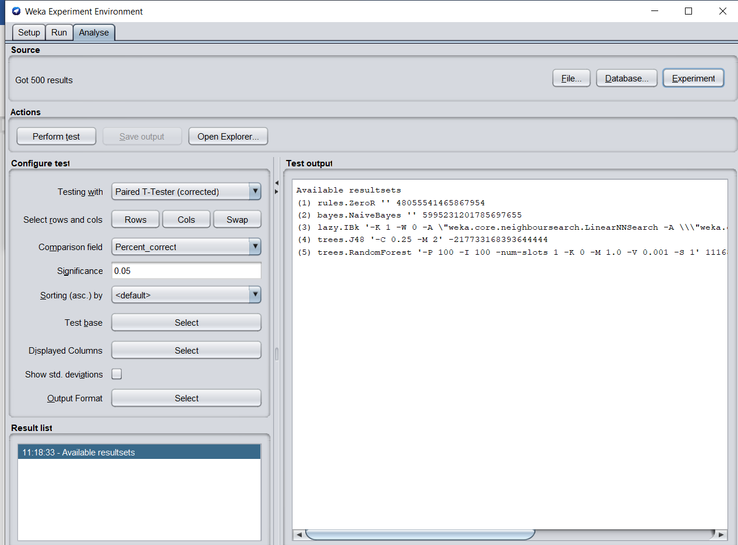

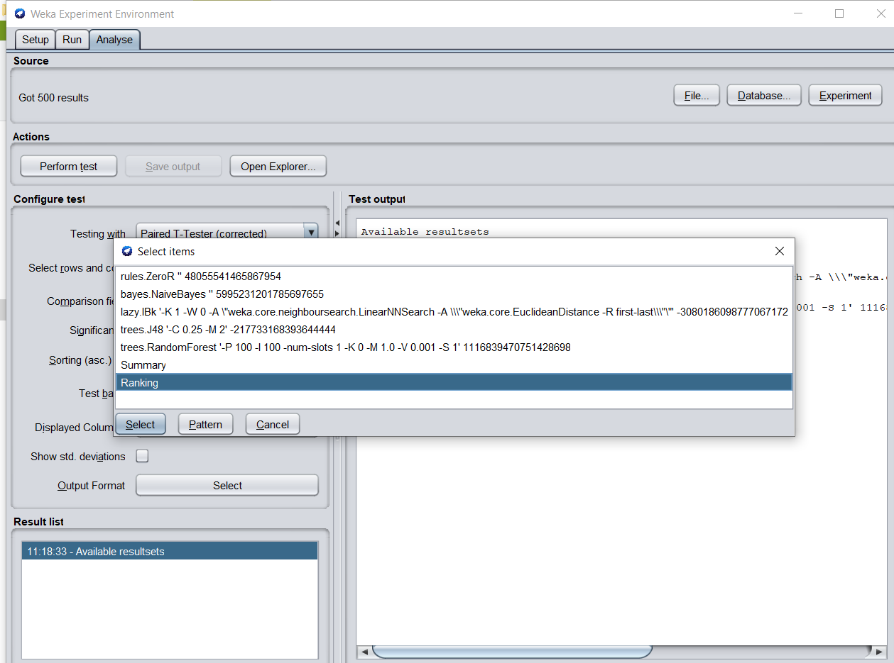

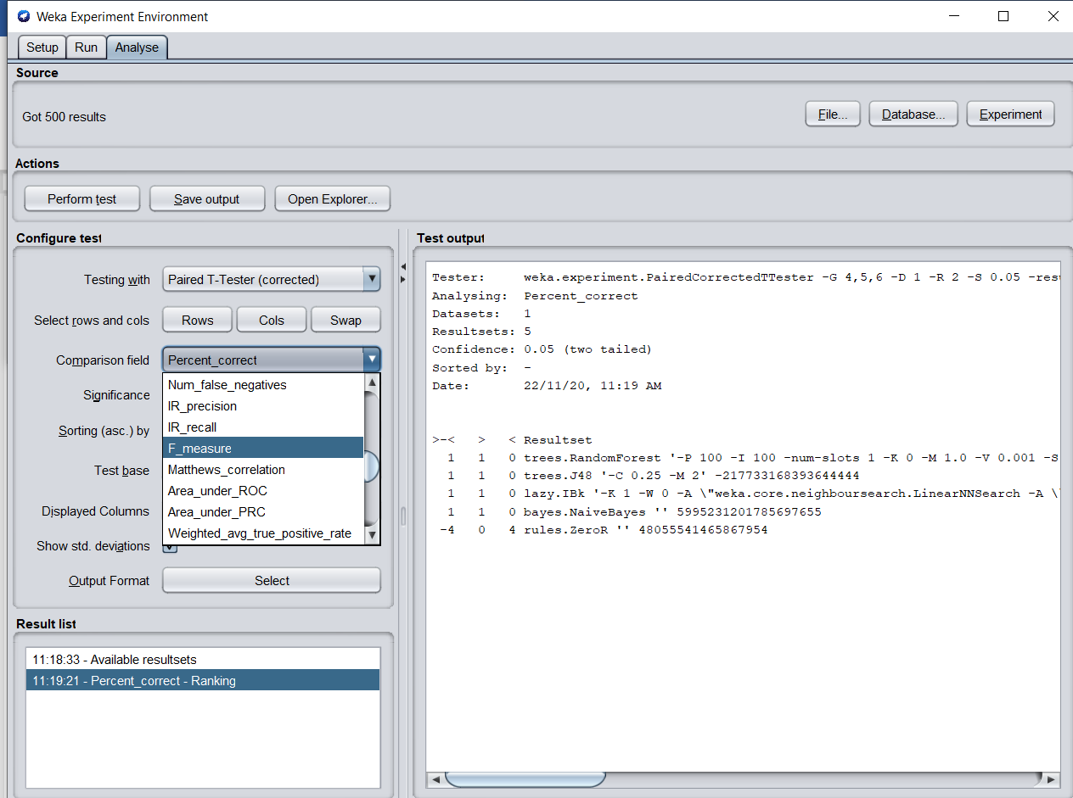

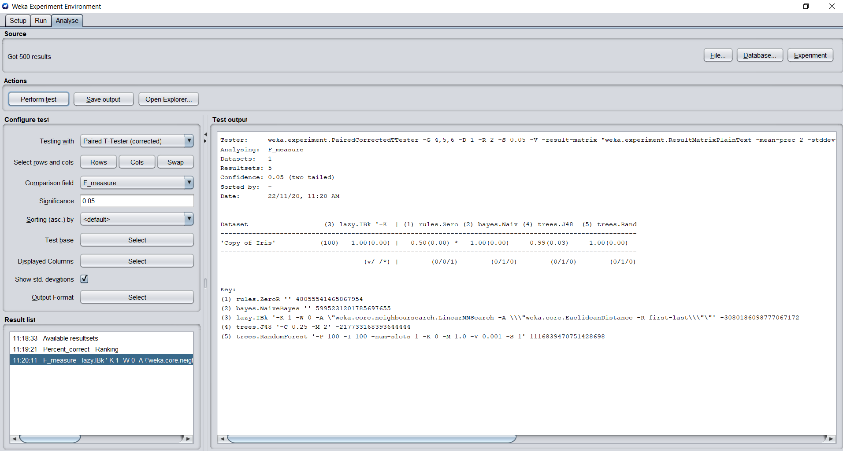

**Learning outcomes (What I have learnt):**

1**.**Learned how to use experimenter tab in WEKA and its features .

2.Learned , performed and analysed the result of 5 machine learning algorithms on the iris dataset .

3. In the above experiment we can conclude that KNN classifier performed based on the dataset

**Experiment - 2.2**

**Student Name: Milan Sharma UID: 23MAI10011**

**Branch: CSE Section/Group: AIML**

**Semester: 1 Date of Performance:**

**Subject Name:** **ARTIFICIAL INTELLIGENCE LAB Code: 23CSH-621.**

**Aim:**

Apply different testing techniques for the UCI dataset and compare the performance of the best prediction model with the following techniques- 70/30 split and K fold cross validation.

**Task to be done:**

* To apply download the dataset from UCL machine learning repository
* Train 5 machine learning repository and choose the best prediction model

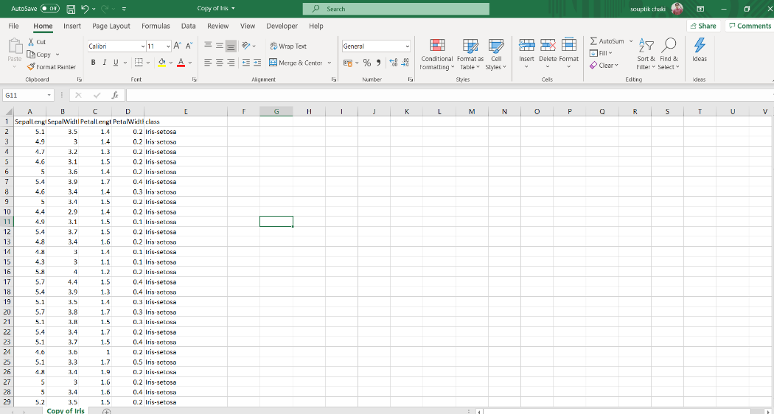

1. **Procedure:**
2. **Tool to be used for given data set :-**

* Open weka and instead of opening the explorer tab open the experimenter tab
* Click on the new option to initiate the process of adding data
* In the dataset section click on Add new option and select the csv file which you want to import.







1. **Train 5 machine learning repository and choose the best prediction model :-**

We can apply the 5 machine learning models as follows:-

* In the algorithms section,click on choose add new> choose>>zeroR
* In the algorithms section,click on choose add new> choose>>naivebayes
* In the algorithms section,click on choose add new> choose>>Randomforest
* In the algorithms section,click on choose add new> choose>>j48
* In the algorithms section,click on choose add new> choose>>IBK(KNN classifier)
* click on Run tab >> click start
* After the execution is completed in run tab >>click on analyse tab
* In the analyse tab >> click on experiment tab >> all the options will become active
* In the configure test section >> click on test base>> and select Ranking>>click on perform test
* After check the result in test area ,it will show the algorithms which have performed better and will display the ranking.
* To check the f-measure and std_dev of an particular algorithm >>click on std_tab >>then select the algorithm which you want to test >> select f-measure from the comparison_fied tab
* click on perform test.









**Run process output:-**



**Analyse process output:-**









**Learning outcomes (What I have learnt):**

1**.**Learned how to use experimenter tab in WEKA and its features.

2.Learned, performed and analysed the result of 5 machine learning algorithms on the iris dataset.

3. In the above experiment we can conclude that KNN classifier performed based on the dataset

**Experiment - 2.3**

**Student Name: Milan Sharma UID: 23MAI10011**

**Branch: CSE Section/Group: AIML**

**Semester: 1 Date of Performance: 23Aug2023**

**Subject Name:** **ARTIFICIAL INTELLIGENCE LAB Code: 23CSH-621.**

**Aim:** Apply K means clustering to sample dataset from UCI Machine Learning Repository. Analyze how parameter tuning affects the results of K means clustering algorithm.

1. **Task to be done:**

* To apply download the dataset from UCL machine learning repositry
* To apply k-means clustering to sample dataset from UCL Machine learning repository
* Analyse the performance

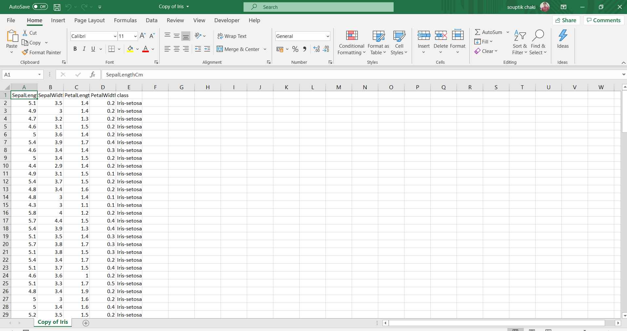

1. **Procedure:**
2. **K-means clustering :-**

* Open weka and instead of opening the explorer tab open the experimenter tab
* Click on the open tab >> select iris dataset >>click on open
* Change the dataset from numeric to nominal >> In filter click on choose>>unsupervised>>attribute>>numeric to nominal
* To apply k-means clustering>>click on the cluster tab >>choose k-means from the clusterer menu
* Click on k-means a dialog box will appear in that >>set numclusters to 3
* Click on use training set and click on start
* Note the values
* Click on use clusters to classes evaluation and click on start
* Note the values

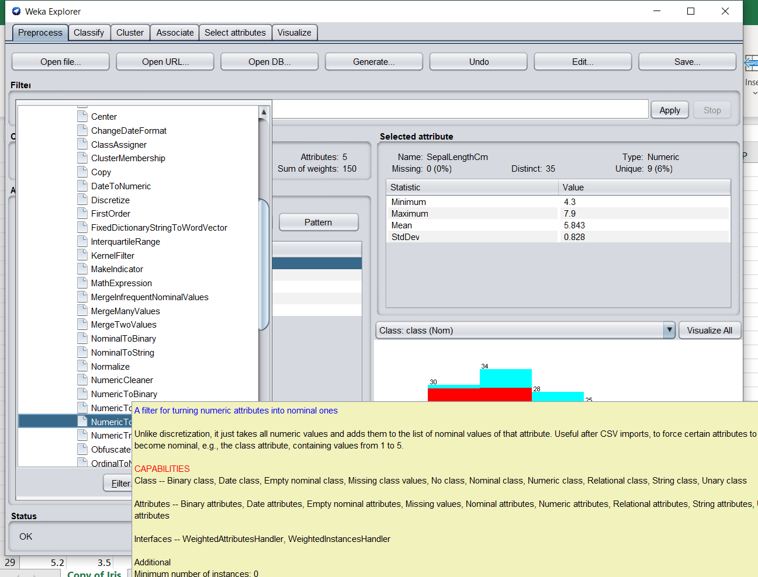

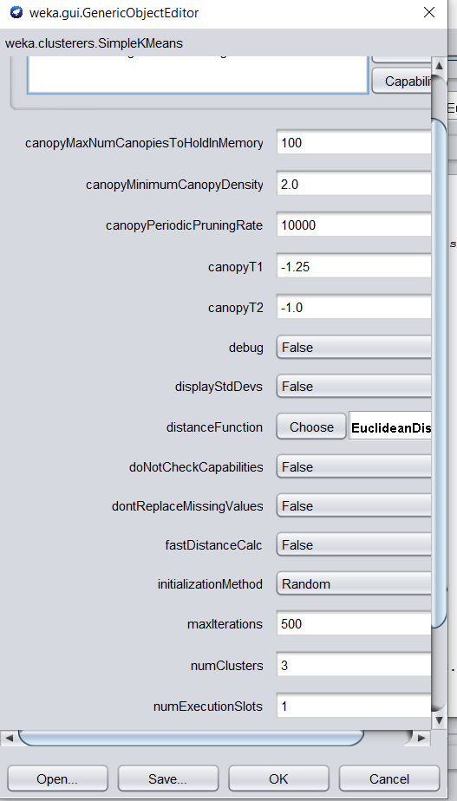

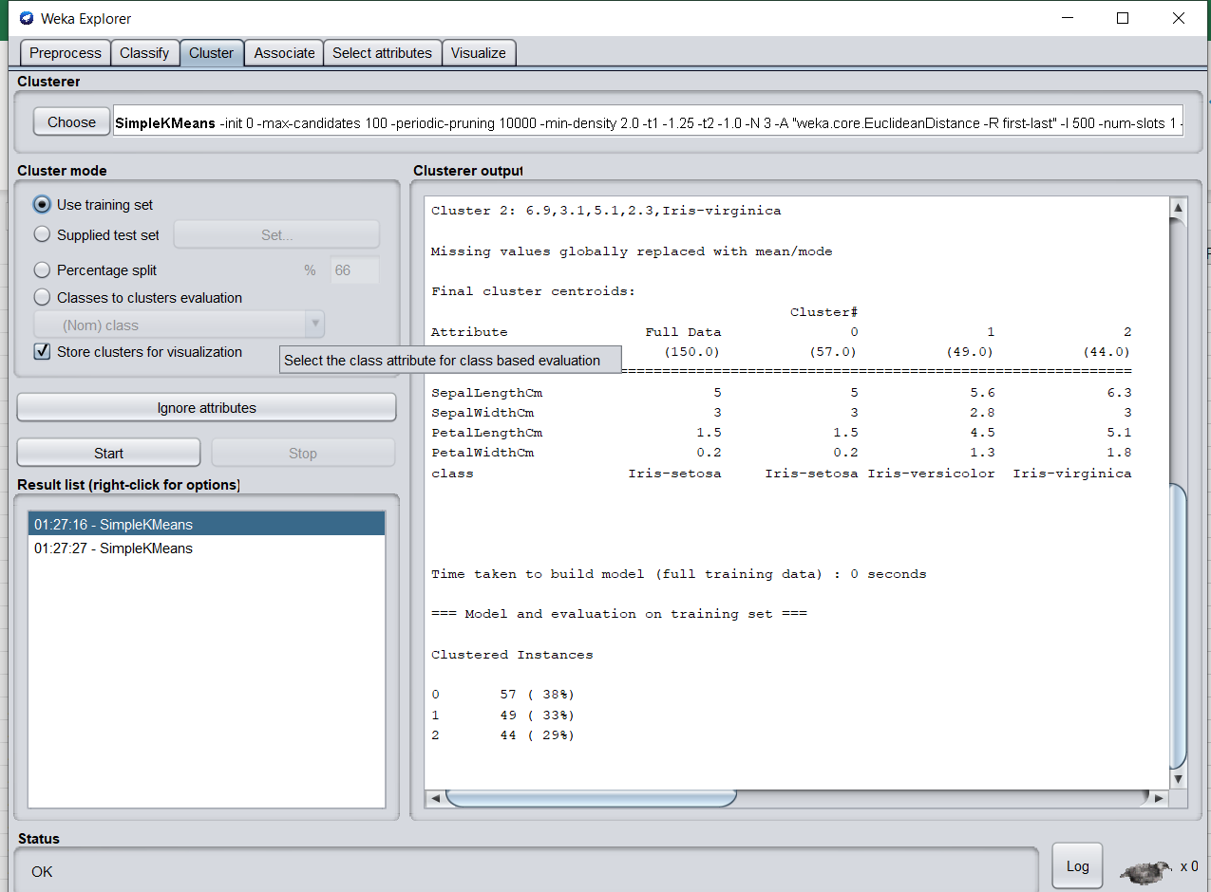

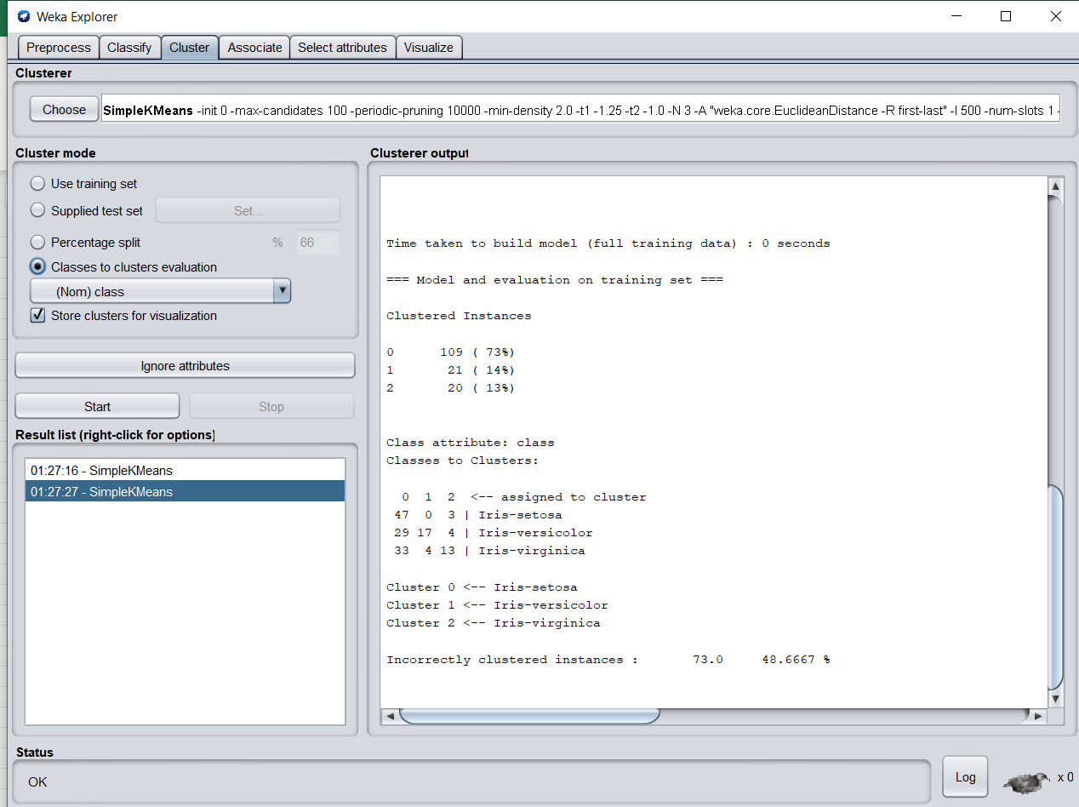

**Learning outcomes (What I have learnt):**

1**.**Learned how to use experimenter tab in WEKA and its features .

2.Learned how to use k-means clustering

3. Learnt how to compare the accuracy of each clusters